Instructions for setting up your server on worldwater.byu.edu:

1. Go to worldwater.byu.edu
2. Click software
3. Click HydroServer Lite
4. Click “Host data at BYU”  
     
   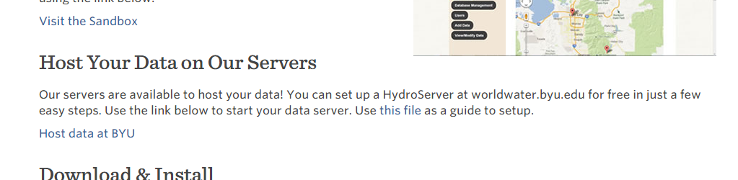
5. Provide a password
6. Choose “Basic” setup type.
7. Choose “Use default database connection”
8. Under “website path” just enter the name of your server, for example “2016Class_Ames”. Please put your name in the name of the server and also the word “2016Class” so that we know we can delete it later. Also note that you can’t have spaces or special characters, but “_” is OK.
9. Set your language (probably English).
10. Set your organization as “2016 Hydroinformatics Class”.
11. Set the parent website name to be 2016 Hydroinformatics Class
12. Set the parent website to be the class web site: <https://usu.instructure.com/courses/417249>
13. Set the variable code as something simple (I used “A”) to mark variables as related to your site.
14. Set the default time support. I used 0.
15. Set the UTC offset for your database. Utah is -7.   
      
    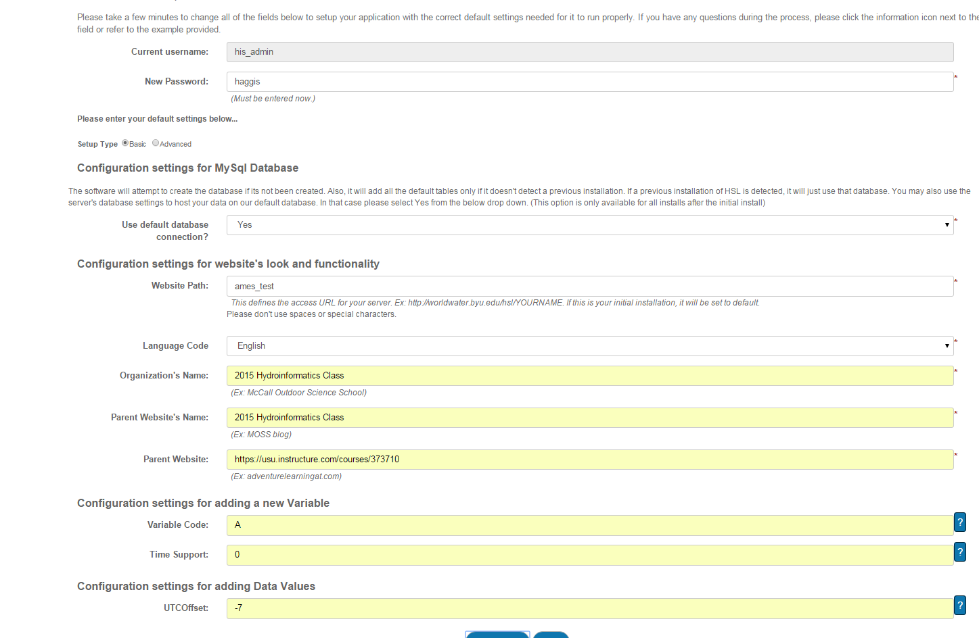
16. Click “Save Settings” and wait up to a few minutes for your server and database to be created. Then you should see this:

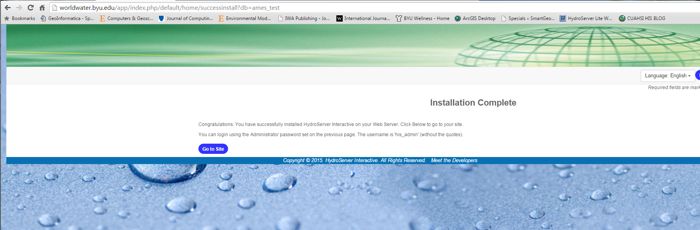

1. Click Go To site. This will take you to the home page for your server: <http://worldwater.byu.edu/app/index.php/ames_test/home>.
2. Log into your site as his_admin and the password you specified when you installed.   
   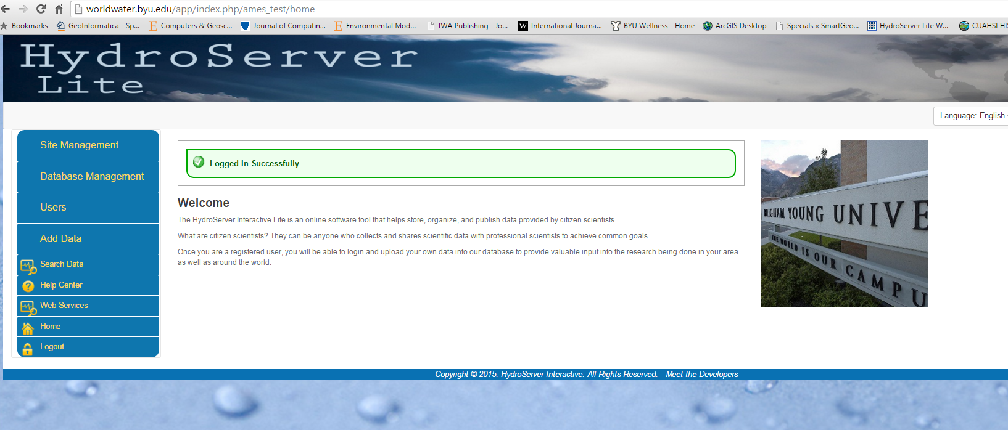
3. At this point, you have a fully functioning HydroServer Lite installation that uses an ODM on the back end. You can edit your ODM using the “Database Management” button. You can add users for your server using the “Users” button. You can add data to your server using the Add Data button. You get the idea.
4. Edit your landing page. You should change the banner and the welcome screen. To do this, click the “Site Management” button.
5. Enjoy. Let me know if you have any trouble. [dan.ames@byu.edu](mailto:dan.ames@byu.edu)